TỔNG HỢP KIẾN THỨC PYTHON TRONG KHOA HỌC DỮ LIỆU

1. **Kiến thức cơ bản về python**
2. Cài đặt môi trường, jupyter notebook ([Link](https://drive.google.com/drive/folders/145Qt_bQ26J53kfG1YpsFf70yXb1K8_XG?usp=drive_link))
3. Python3 cú pháp cơ bản ([Link](https://drive.google.com/file/d/1fD8PNHKXAjfQSabGruIzCfGhzjMIf4Il/view?usp=sharing))
   1. Comments

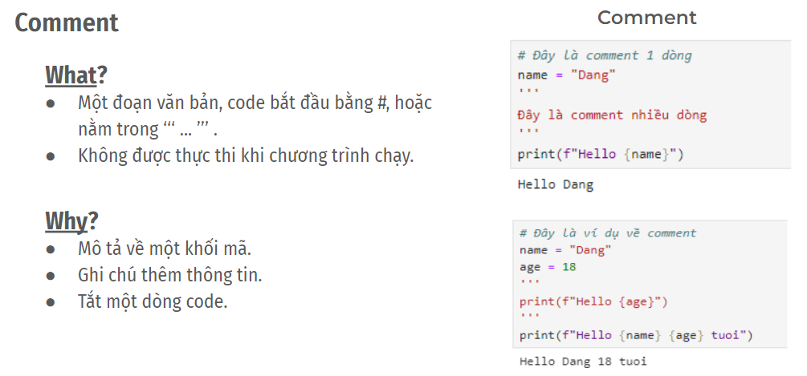

* 1. Data types - kiểu dữ liệu

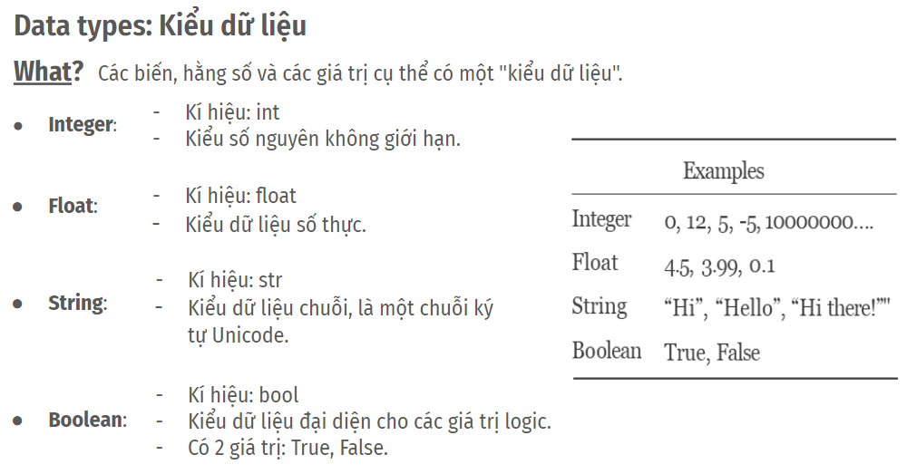

* 1. Variables - Biến

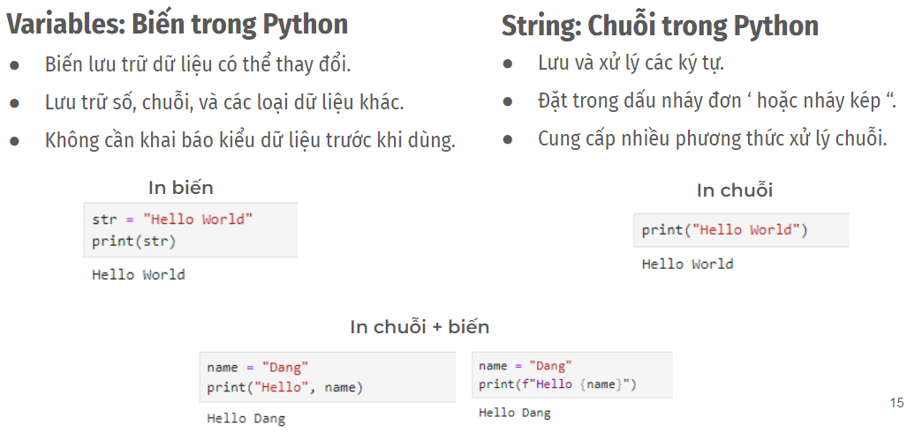

* 1. Operators - Toán tử

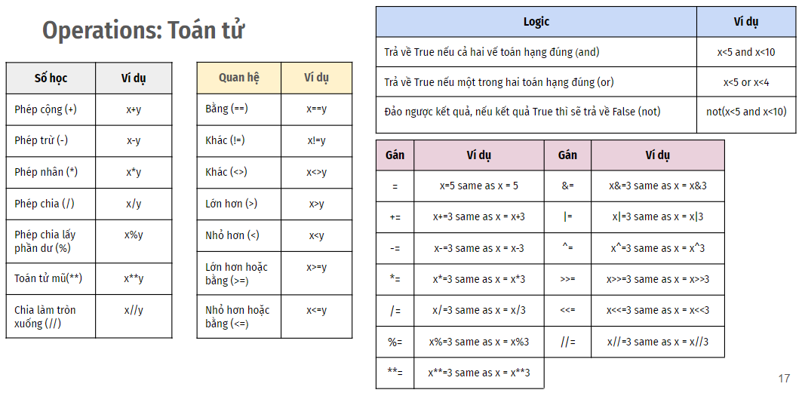

* 1. If/else - Câu điều kiện

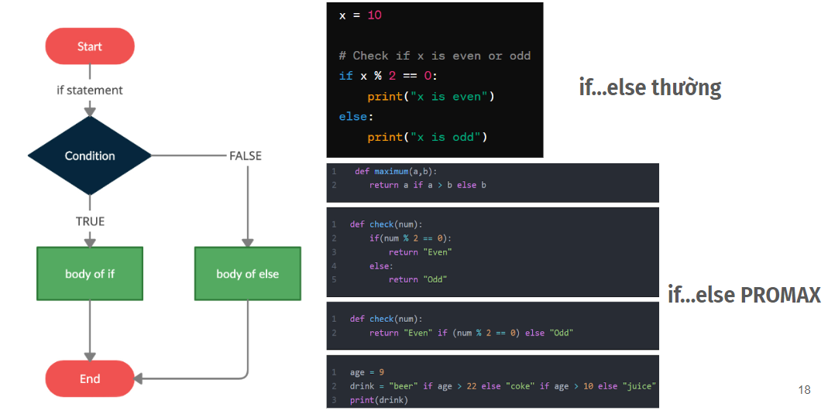

* 1. Loop - Vòng lặp (For, While, Switch case)

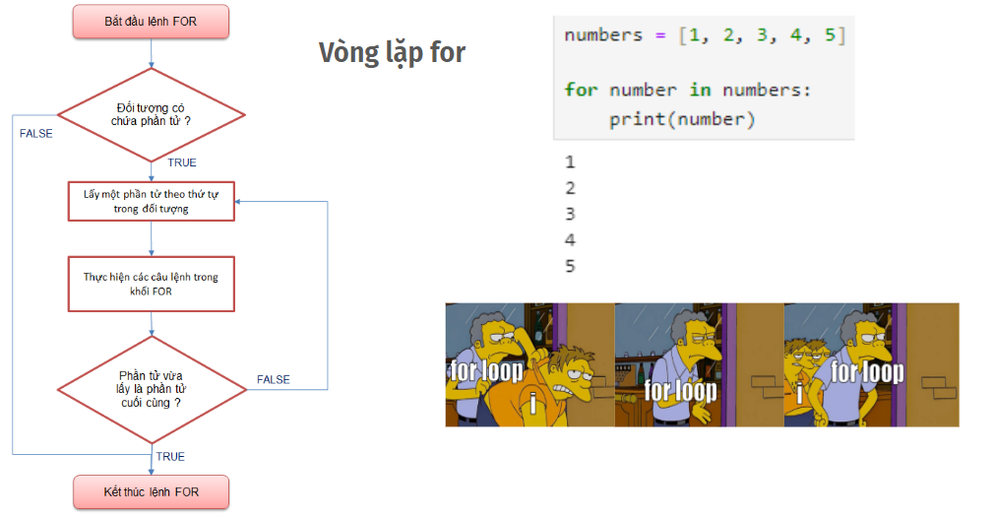

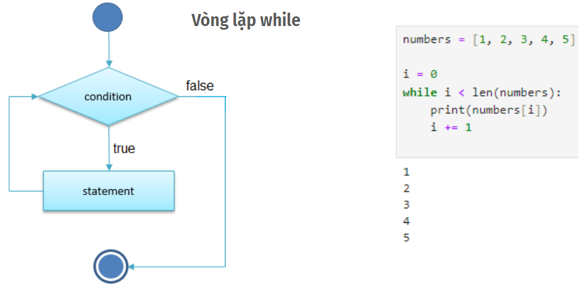

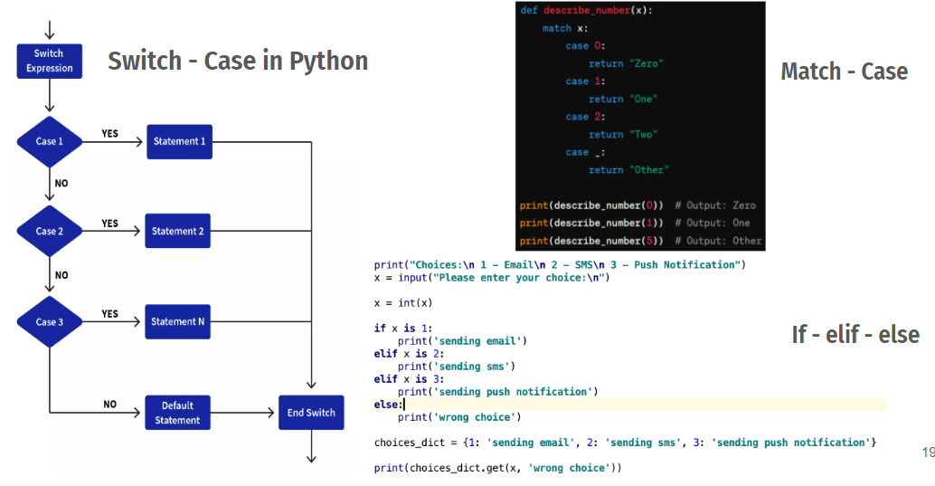

1. **Cấu trúc dữ liệu trong Python (**[**Summary**](https://drive.google.com/file/d/1AaOsf2QxCUwk7ks9ikY7gtGvRbBIg_e9/view?usp=sharing)**)**
2. Lists - danh sách ([Link](https://drive.google.com/file/d/16anzbAVO7QcwVS59w8nZIE9QaA50CwTo/view?usp=sharing))

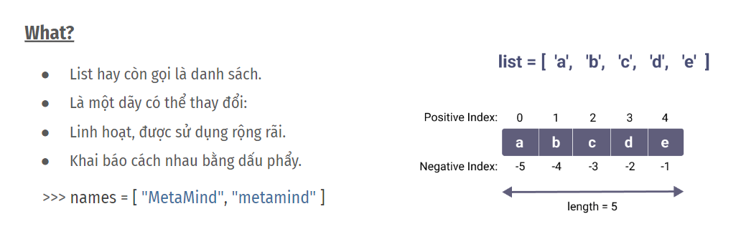

1. Tuples ([Link](https://drive.google.com/file/d/1JhIUgUU_JMTunlzA_fsA5v5_C643l6zT/view?usp=sharing))

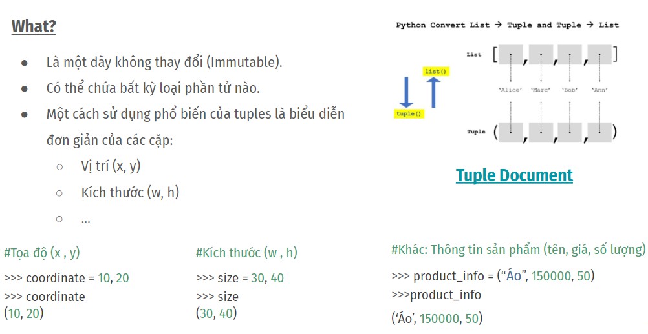

1. Sets - Tập hợp ([Link](https://drive.google.com/file/d/1paWMBa6vhXqdQFyUvukAQJYtLvd2mZ7D/view?usp=sharing))

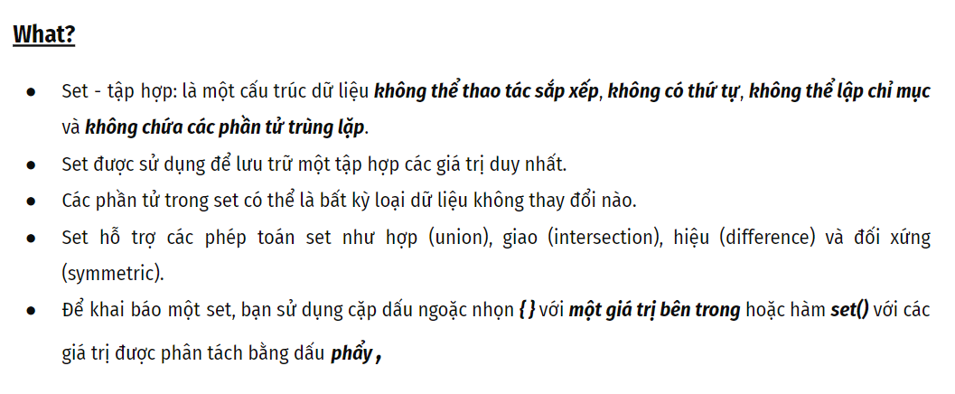

1. Dictionary - Thư viện/Bảng băm ([Link](https://drive.google.com/file/d/18SOxMr3nze9CqTNSc2C12Ny-mHTQv8uO/view?usp=sharing))

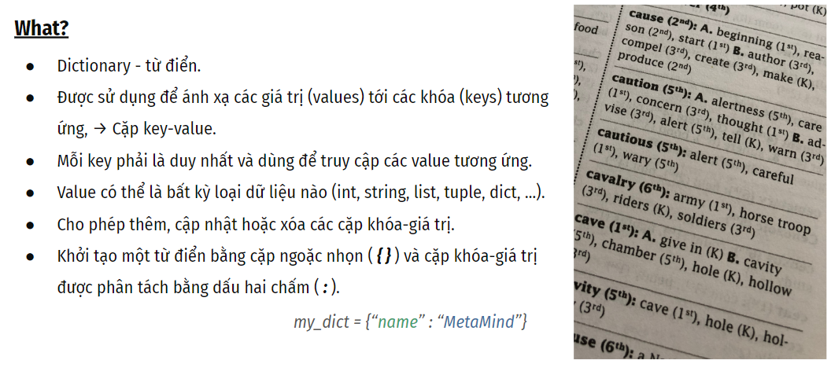

1. **Python nâng cao**
2. Biểu thức chính quy Regex ([Link](https://drive.google.com/file/d/1B9PyDvQlWccGcc3SdRd_t6xkTtQwkhBC/view?usp=sharing))
3. Xử lý ngoại lệ ([Link](https://drive.google.com/file/d/1SwZfoeoC4UTqzB7qPDrlFhHVLn7EBfmf/view?usp=sharing))
4. Xử lý file ([Link](https://drive.google.com/file/d/1ncWwYMkZUbLBE9lBW_bthm7W4HqydH0J/view?usp=sharing)) ([File](https://drive.google.com/file/d/1HHY53J9pNfxtRNrjdhnpA1mH_jE1Ff-y/view?usp=drive_link))
5. Phân chia module ([Link](https://drive.google.com/file/d/1-KF3jz49jhQ9HYtgYVx095OFSq48u1yC/view?usp=sharing)) ([Sample](https://drive.google.com/file/d/1aCEOPdX47x9wxPi3vIWvvxIOBfItEzuB/view?usp=drive_link))